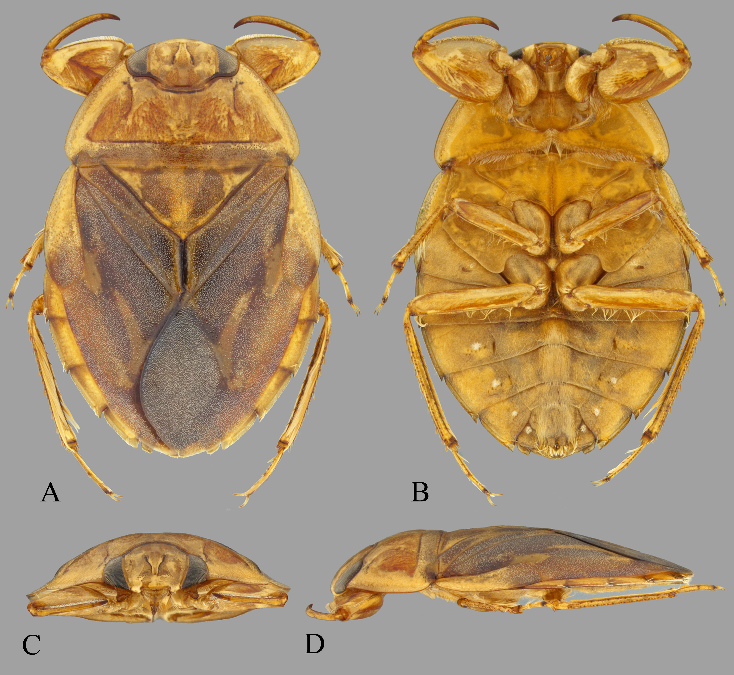
Figure 1. Female of Ambrysus signoreti. (A) dorsal habitus, (B) ventral habitus, (C) frontal view of head, prothoracic legs, and prothorax (D) lateral view of left side.

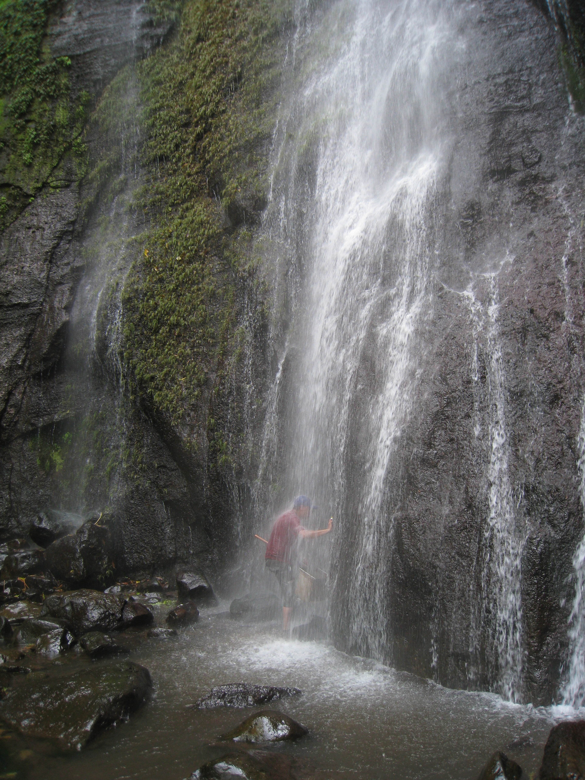
Figure 2. DRV collecting specimens of the genus Cataractocoris at El Arcoiris waterfall in Veracruz, Mexico.
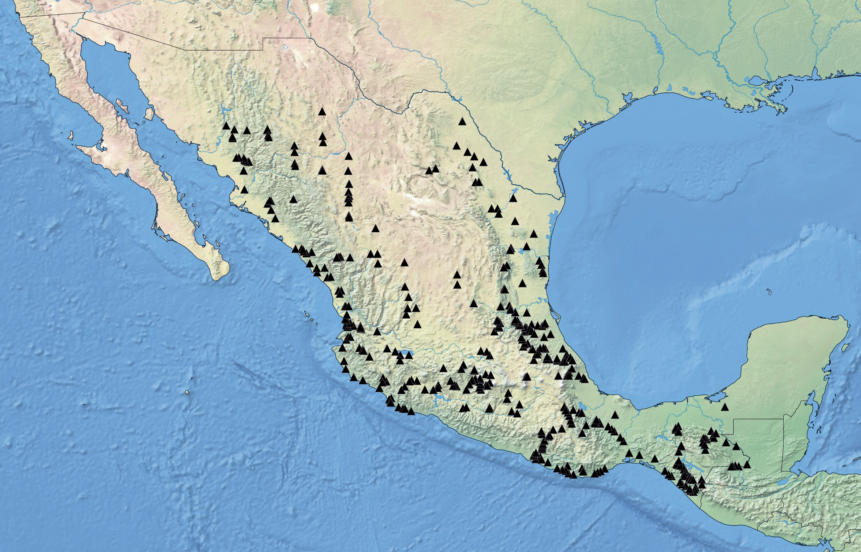
Figure 3. The 432 localities where we collected samples for the project on the Mexican fauna of Naucoridae.

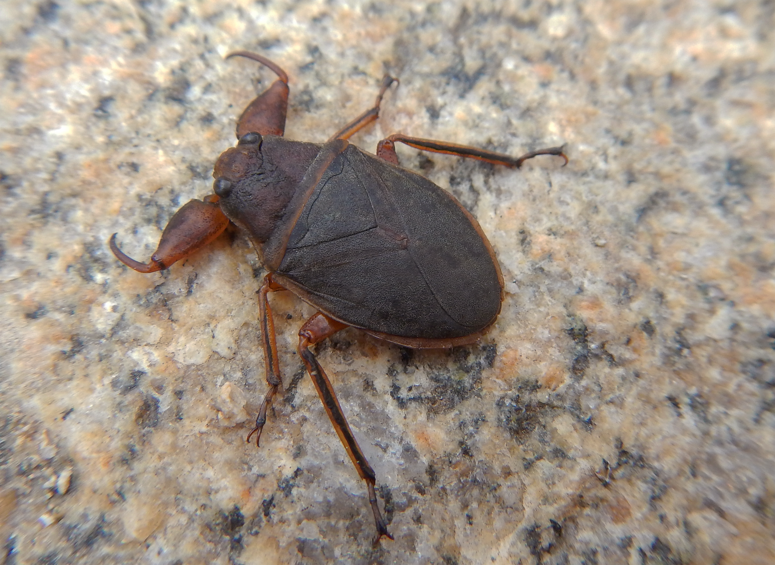
Figure 4. Staged specimen of Cataractocoirs macrocephalus (Río Rana, Oaxaca).

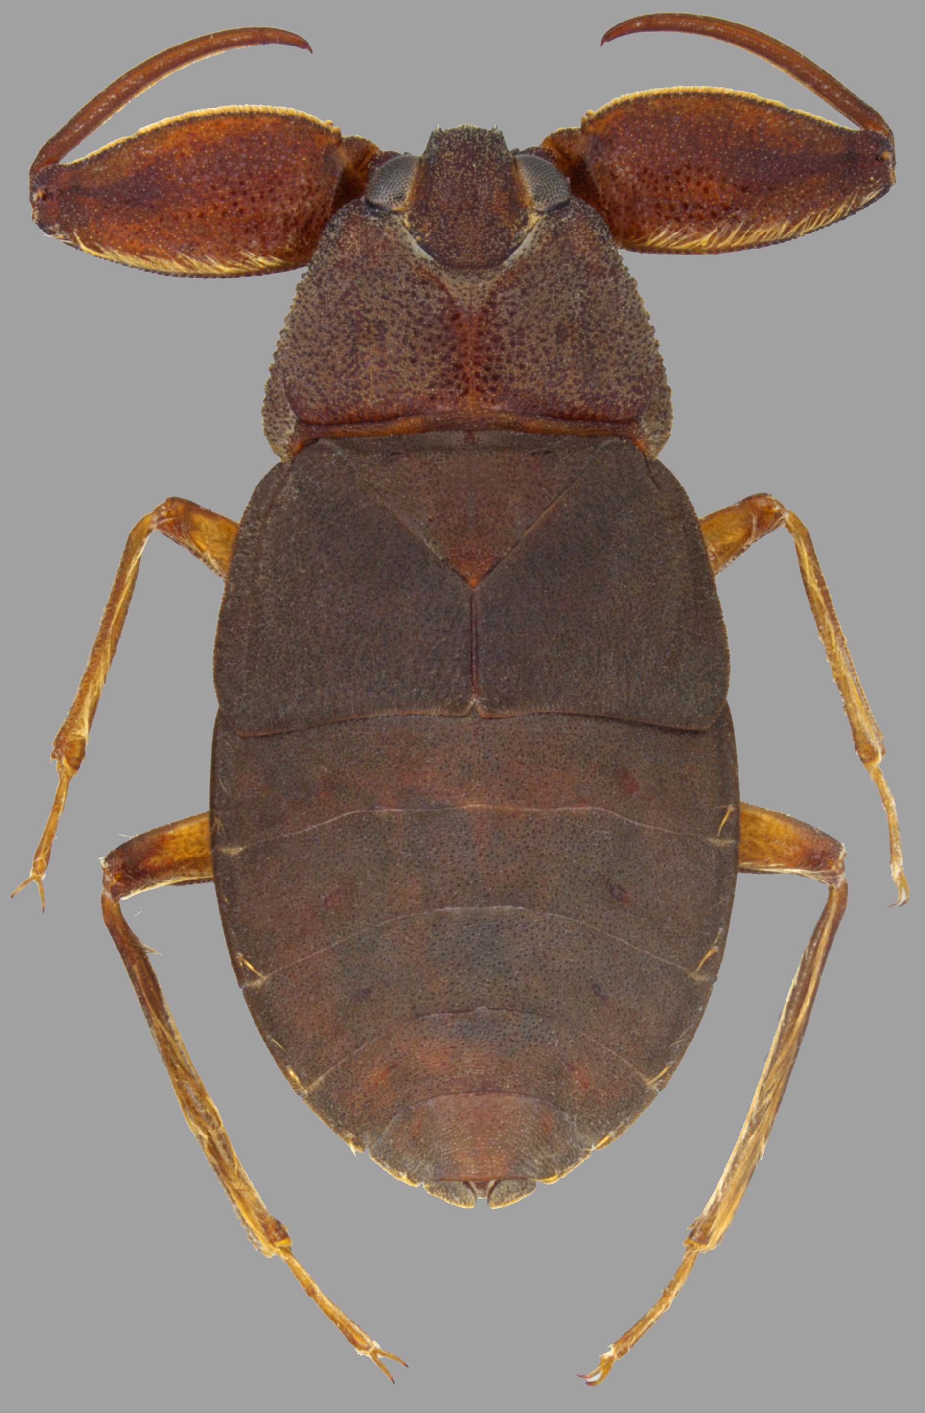
Figure 5. Brachypterous female of Cryphocricos hungerfordi (Altotonga, Veracruz).

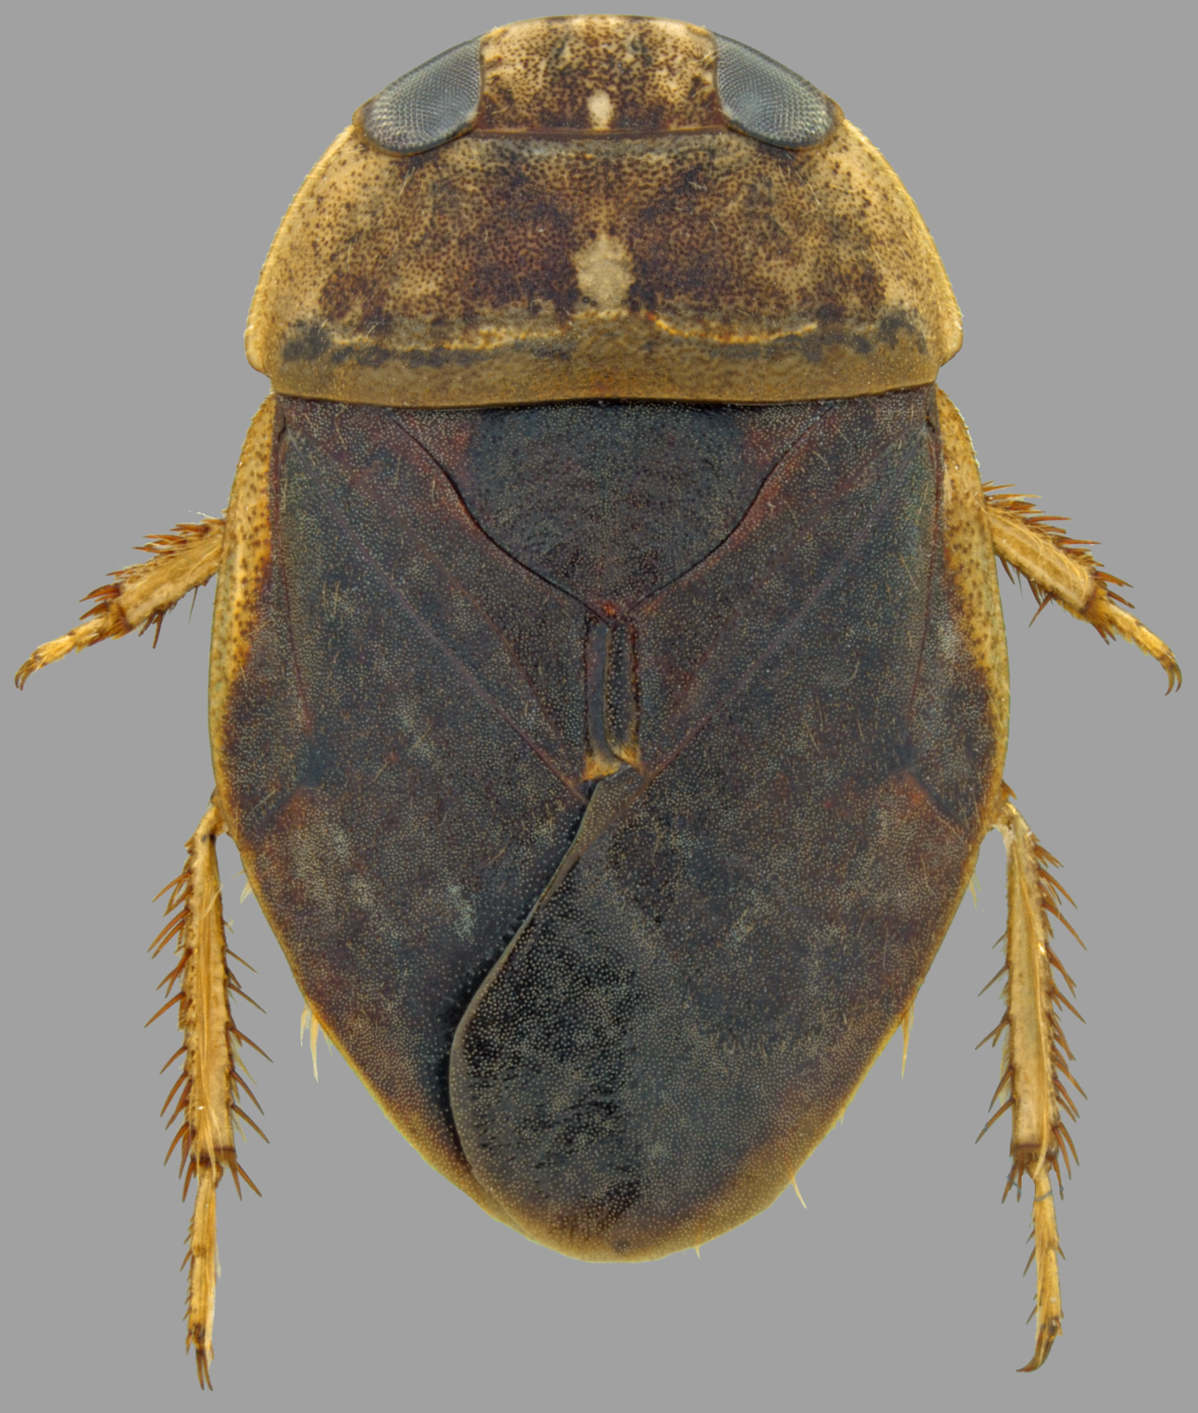
Figura 6. Male of Interocoris mexicanus (Motocintla, Chiapas).

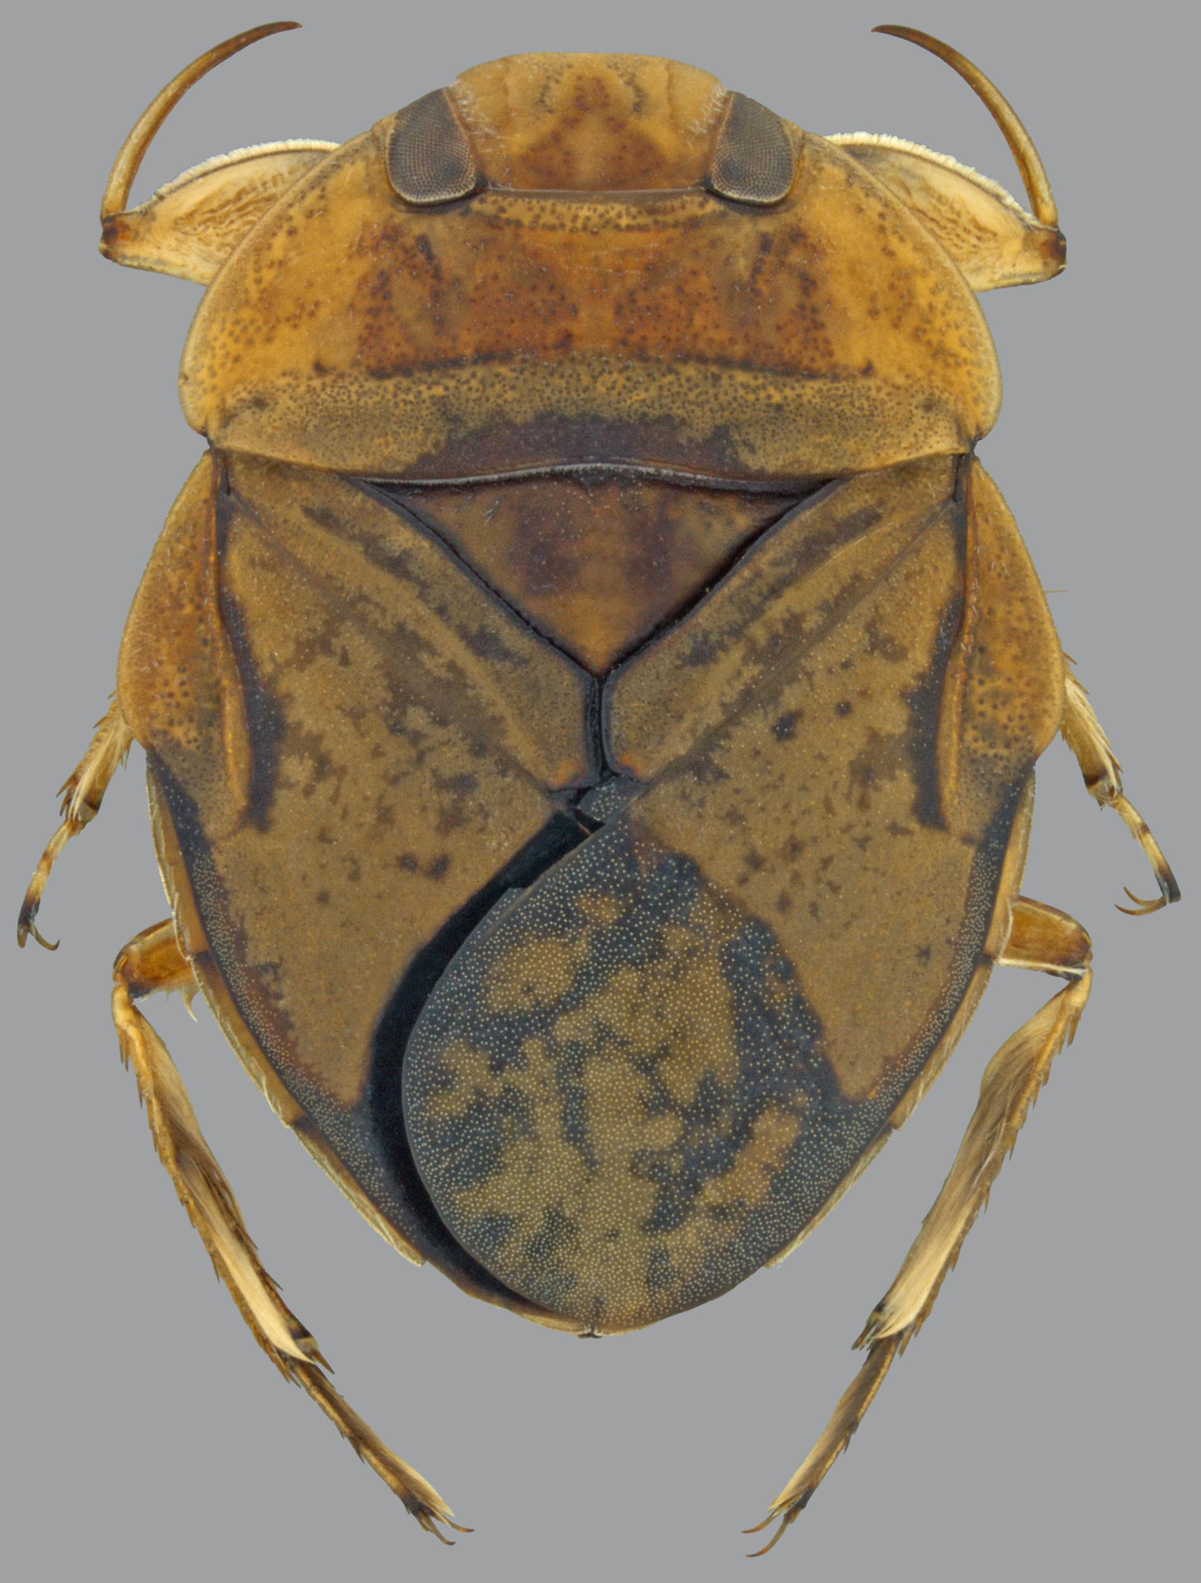
Figure 7. Male of Limnocoris signoreti (Putla de Guerrero, Oaxaca) (det. H.D.D. Rodrigues).

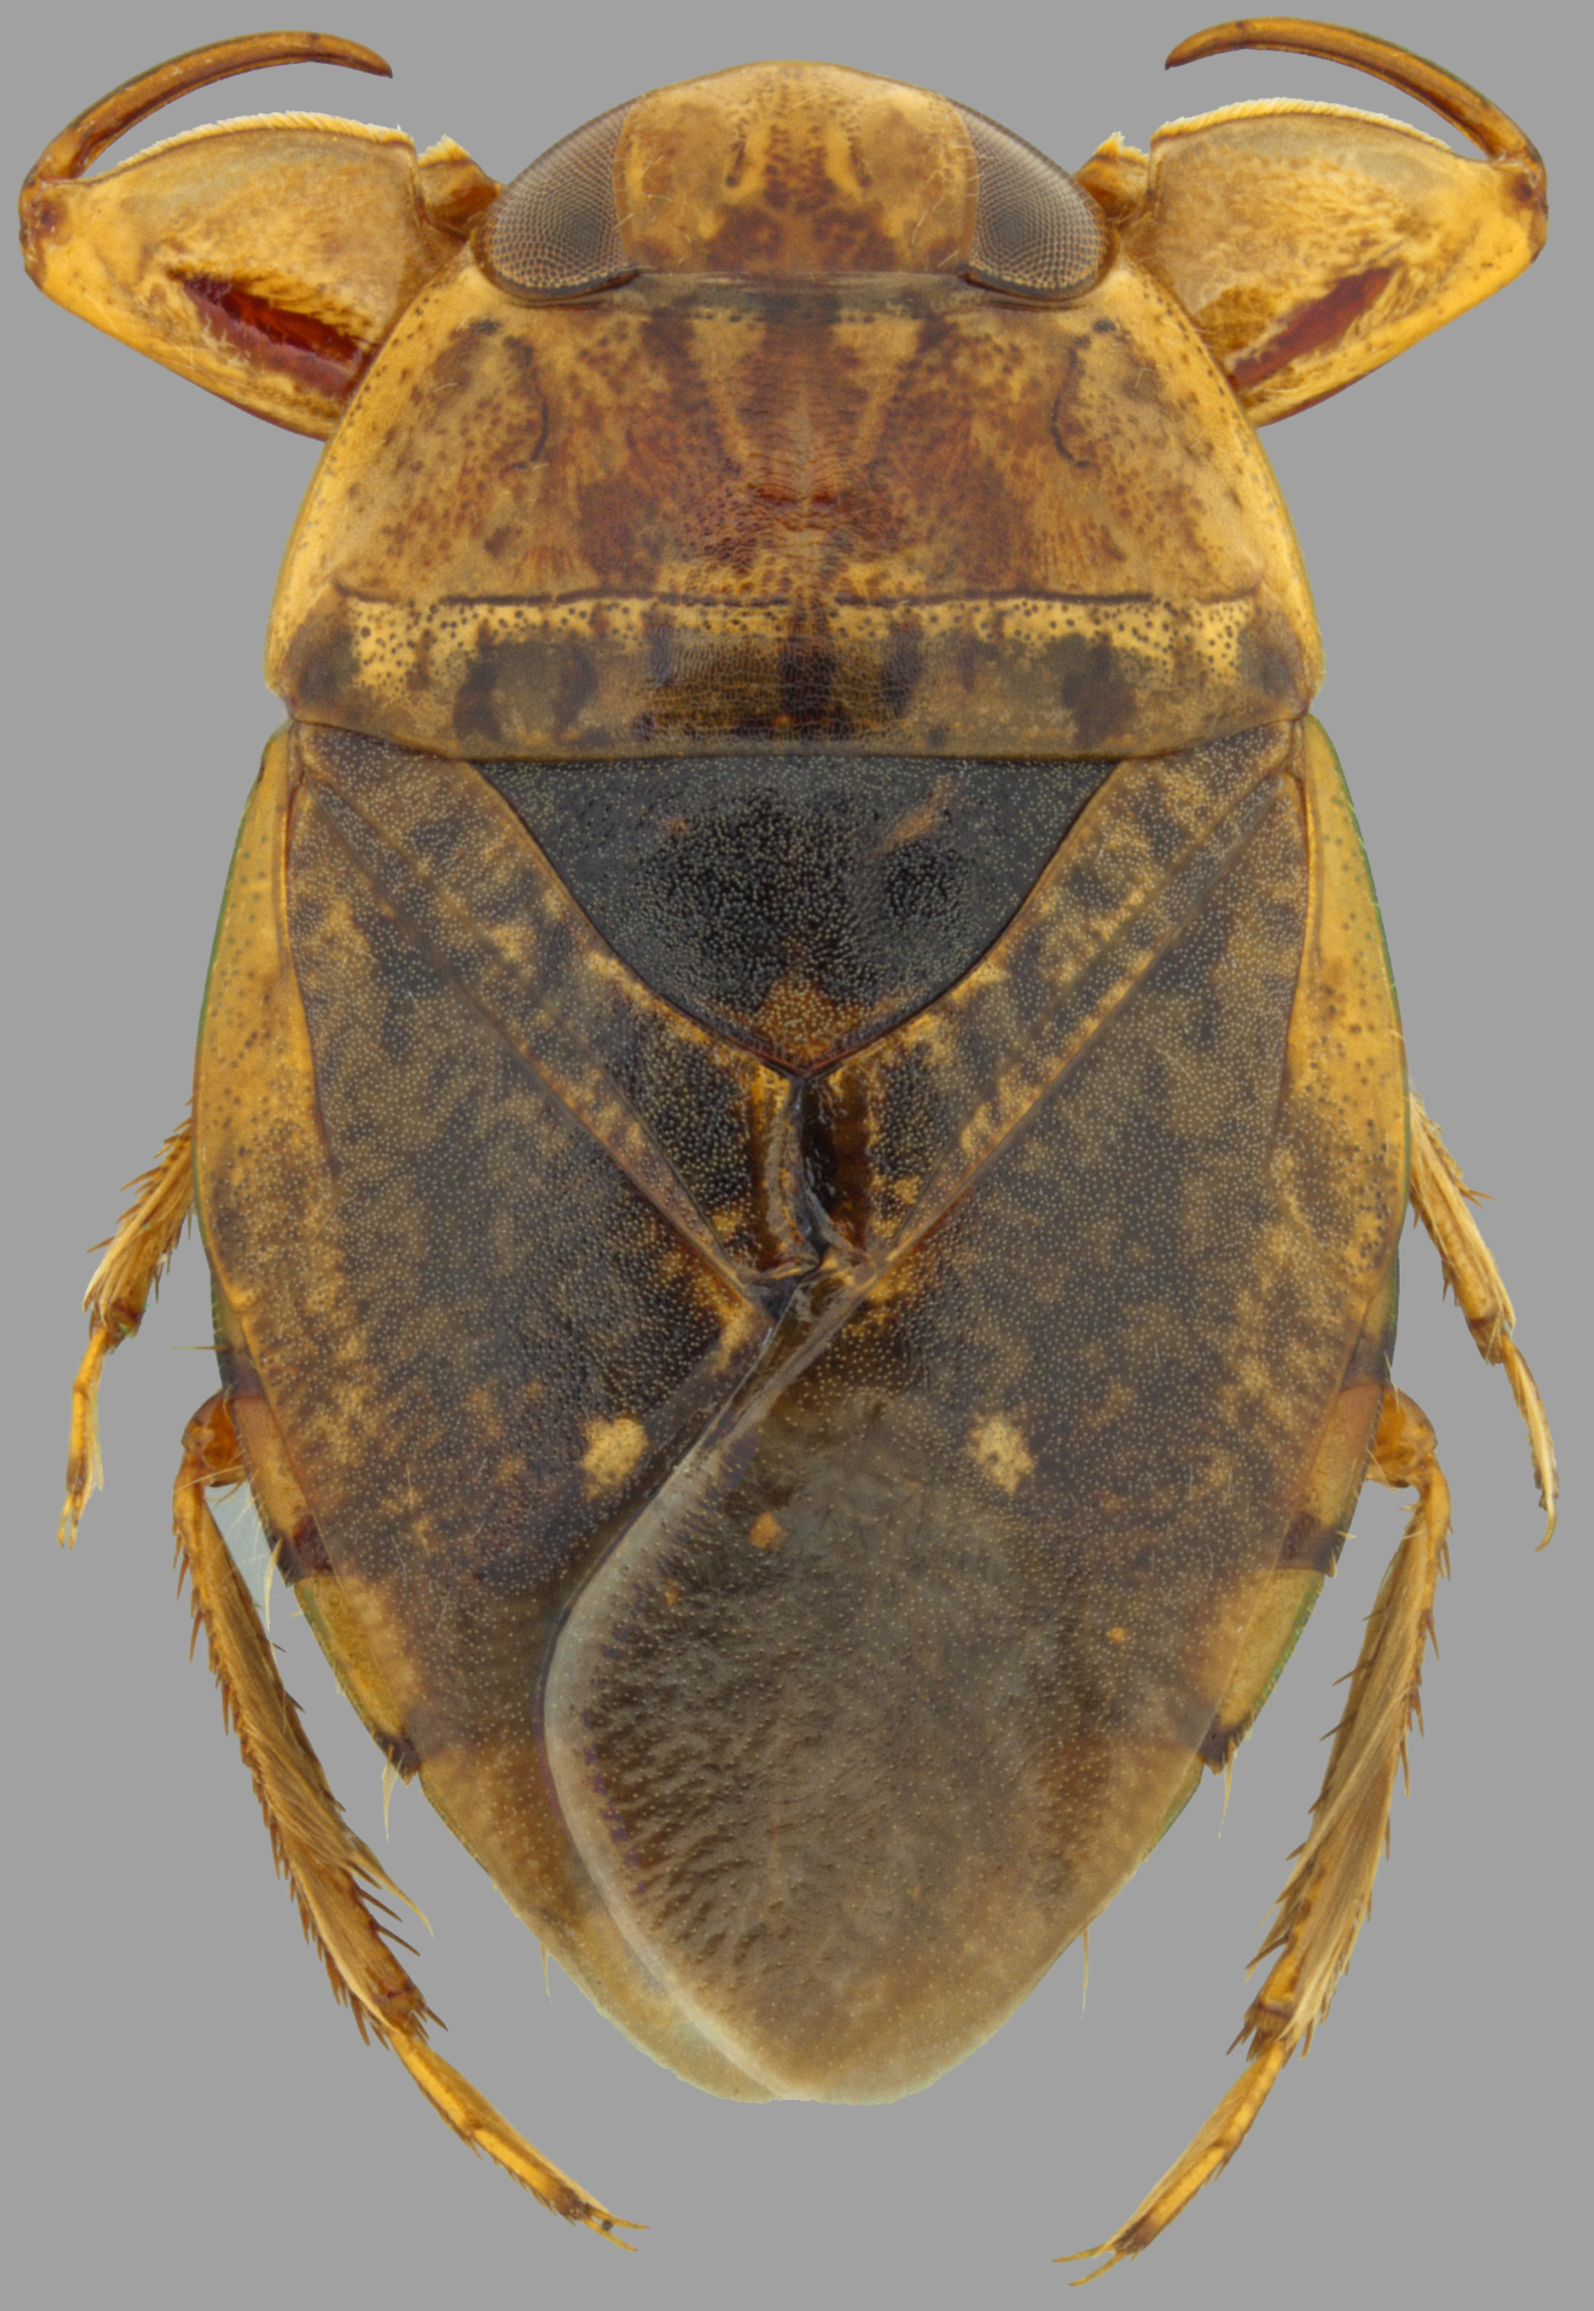
Figure 8. Female of Pelocoris biimpressus (Los Sabinos, Michoacán).

