Figure 6.- Annual variations in the larval density of S. maroccana in cantons A-E of the Mamora Forest (2007- 2008 to 2012-2013).

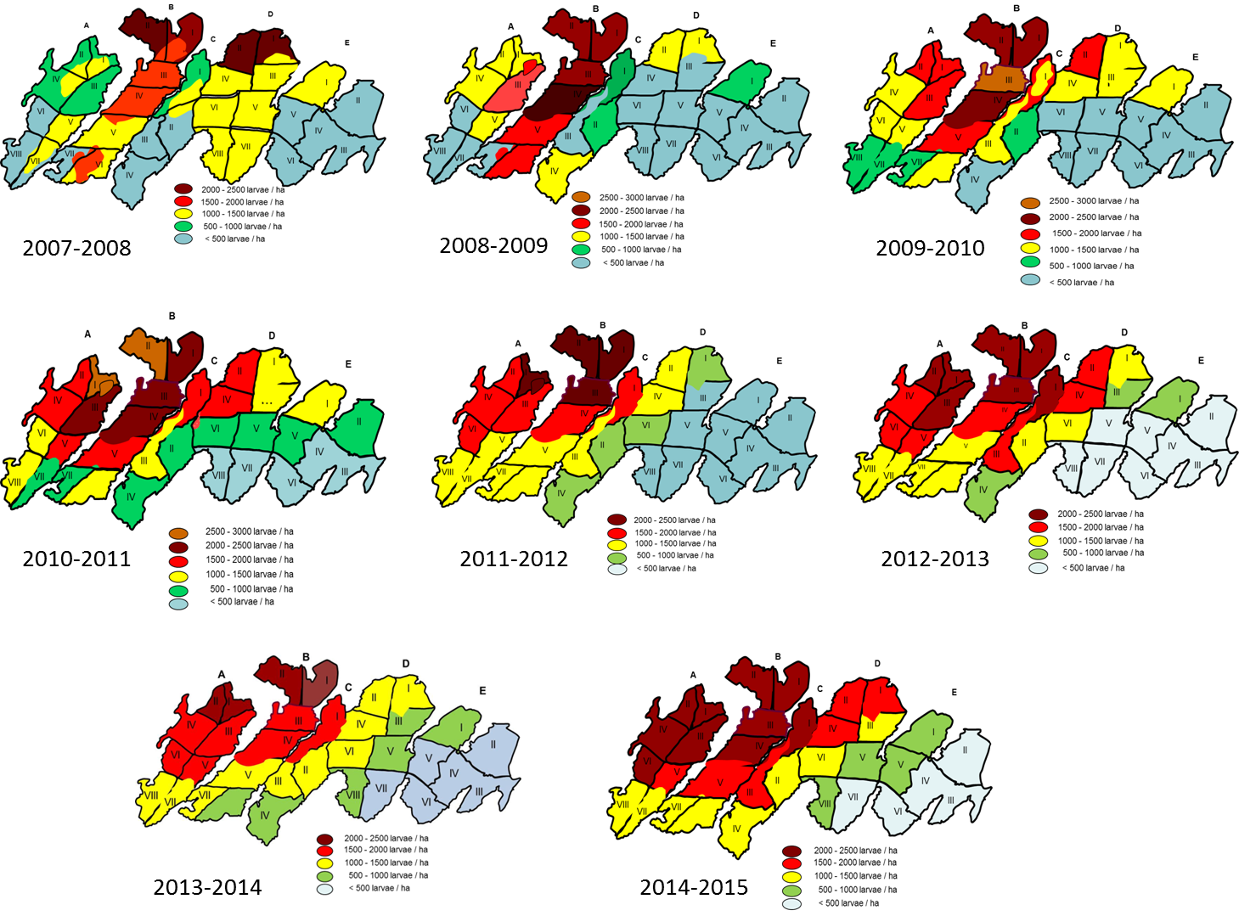

Figure 6.

