Figure 5.- Differences in soil depth (Mamora Forest, cantons A to E).

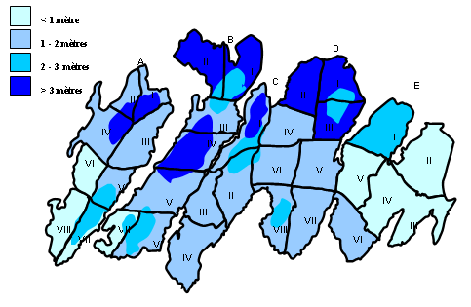
Figure 5.

