Figure 4AB.- (A) Presence of Sphodroxia maroccana larvae at the root level; (B) Death of seedlings following an attack on roots.

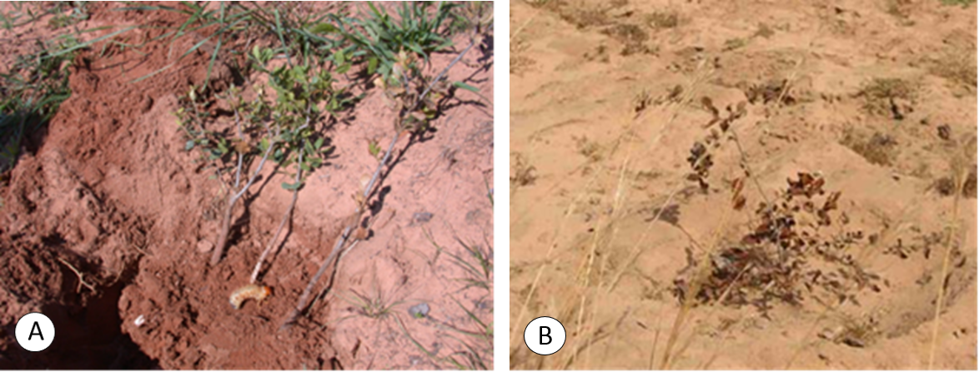
Figure 4 (A- B)

